Overview: Safewards Model
Safewards in Emergency Departments - Trial

Safewards is a model that aims to improve safety for both patients and staff, with a focus on reducing conflict (anything that could be harmful for a patient, staff or others) and containment (restrictions placed after the conflict event).
Safewards was developed in the UK. It has a strong and growing evidence base from around the world and here in Victoria. It includes an exploratory preventative model and ten interventions.
Staff and patient modifiers in the Safewards model identify opportunities to prevent conflict and containment or reduce its impact. The Safewards interventions provide practical ways to use these modifiers. The interventions are actions that are taken to increase safety and mutual support for staff and patients.
Safewards flashpoints
Flashpoints
Flashpoints are times or situations when things could go wrong. They arise out of the originating domains, and they’re like ‘triggers’ or ‘tipping points’ that signal and precede potential conflict.

Staff can prevent flashpoints by understanding and responding to domains before there is a problem.

Staff can reduce the likelihood of conflict by how they respond to flashpoints. Even if conflict occurs, staff can learn and use strategies other than restrictive interventions.

Originating domains
There are six originating domains, and they represent different aspects of the emergency department that can affect conflict and containment (see below). Research tells us these domains can create potential flashpoints.

Staff are encouraged to think about the domains for each patient.

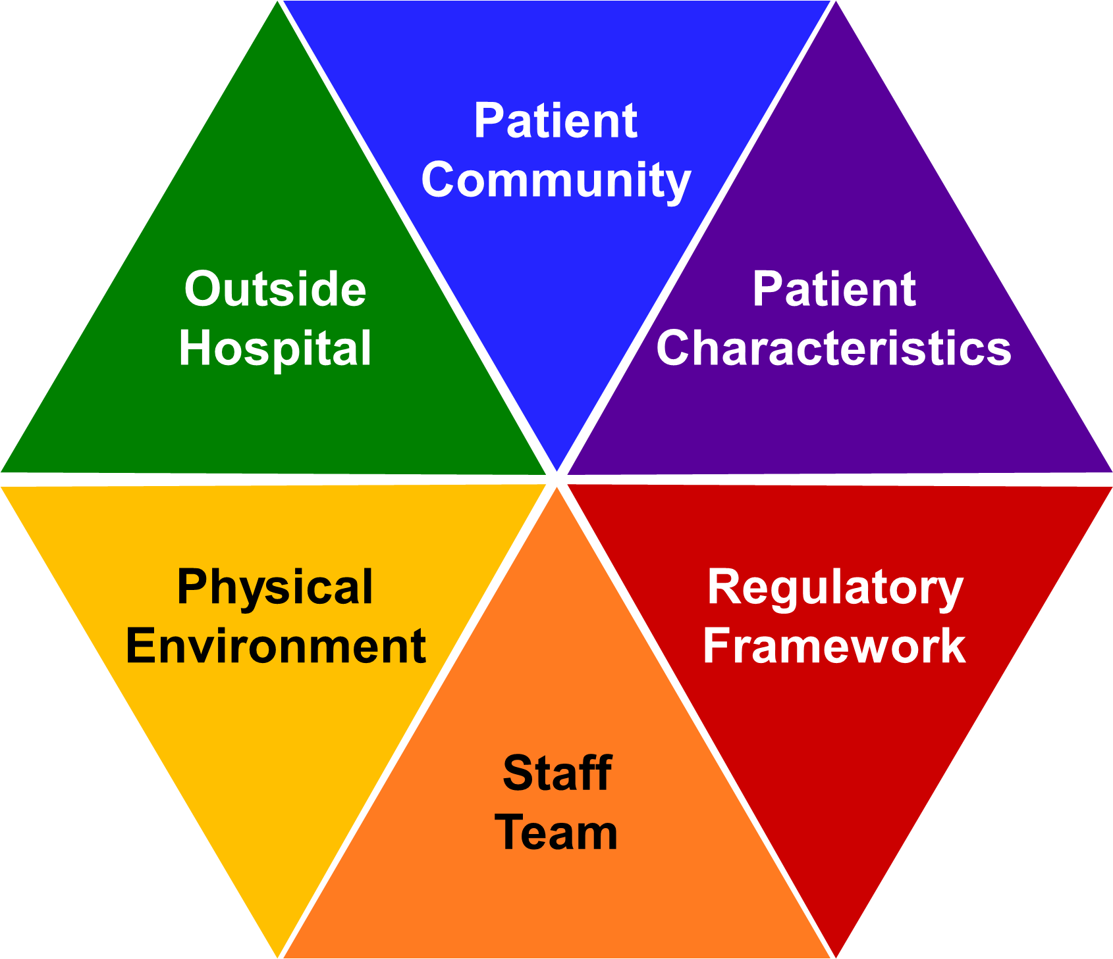
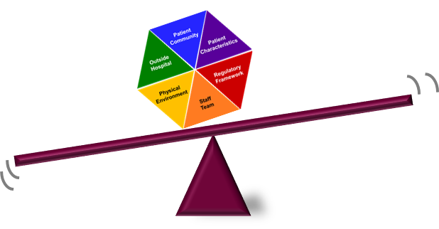
Safewards originating domains
This information was adapted from material developed by Professor Len Bowers, UK.

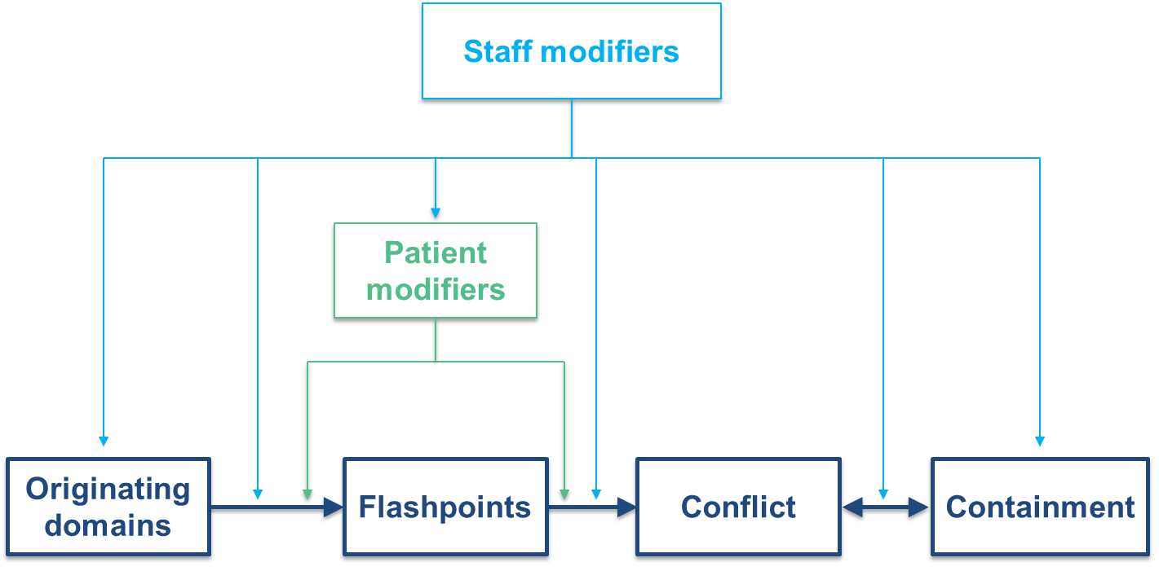

The Simple Safewards Model
Overview: Safewards Interventions
Safewards in Emergency Departments - Trial

The Safewards model and approach to care identifies these ten interventions as relevant to ED.
Each intervention is explained in more detail on the Safewards Victoria website: www.health.vic.gov.au/safewards
Reassurance
Staff touch base with every patient after any conflict and debrief as required.
Reduces a common flashpoint, increases patients’ sense of safety & security

Delivering Bad News
Staff proactively plan for the effects of bad news received by patients.
Reduces impact of common flashpoints, offers extra support

Respectful limits
Staff reduce the limits faced by patients, create flexible options & use respect if limit setting is unavoidable.
Reduces a common flashpoint Builds respect, choice & dignity

Calming Methods
Staff support patients to draw on their own strengths.
Strengthen patient confidence & skills to cope with distress

Talk Through
Focuses on clarifying issues and finding solutions together. Staff work with respect & empathy.
Increases respect, collaboration & mutually positive outcomes

Know Each Other
Patients & staff share some personal interests & ideas with each other, displayed in common areas.
Builds rapport, connection & sense of common humanity

Positive Words
Staff say something positive in handover about each patient. Staff take great care with their use of collaborative language, building on the positive aspects of the patient.
Increases positive appreciation & helpful information for colleagues to work with patients

Senior Safety Round
Senior nurse checks in with patients to ensure they have been heard and feel safe.
Leader ensures the patient experience has been positive

Perception and Awareness
Staff increase their awareness of the patient experience and perception of events.
Minimises potential aggression events and capitalises on patient self-coping and help/protection strategies

This information was adapted from material developed by Professor Len Bowers, UK.

