Physiotherapy Department
Bendigo Health
Phone: (03) 5454 8783 Fax: (03) 5454 9041
Monday to Friday 8:30am – 5:00pm

LOAN OF CRUTCHES INFORMATION

This equipment is on loan to you free of charge for 30 days from date of loan.
After the 30 day period a one-off hire fee of $30.00 applies to this loan. This is a non-refundable fee.
If the crutches have not been returned after the 30 days, an invoice for the $30 fee will be forwarded to you. You may continue to use the crutches as needed.
We have a limited stock of these items and many patients needing them. We would appreciate prompt return of this equipment once you no longer need it.

Return of crutches
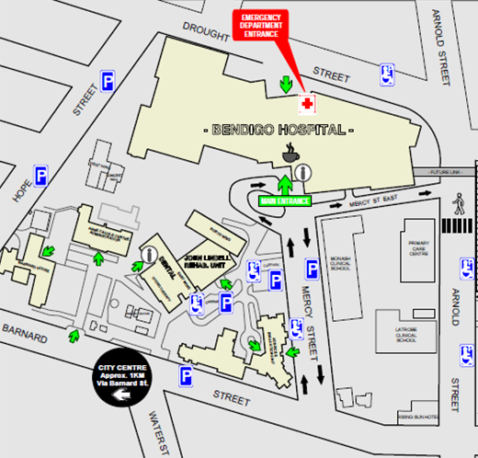
From Feb 13 2017, please return to John Lindell Rehabilitation Unit (JLRU) reception. Thank you.

Allied Health – Mercy Street
Report to Reception at John Lindell Rehabilitation Unit
Parking and entry via Mercy Street only

Note: Equipment is also available to hire/purchase from local pharmacies and medical supply shops.

HOW TO USE CRUTCHES

Non-weightbearing (NWB) or touch-weightbearing (TWB)

Ensuring your affected leg stays off the ground, place crutches in front
- Take your weight through your arms by pushing down through your hands, elbows straight, NOT by leaning on the top of the crutches
- Hop forward
- Once balanced/confident, continue.

Partial weightbearing (PWB) / weight bearing as tolerated (WBAT)
- Place crutches in front of you
- Take some weight through your arms by pushing down through your hands
- Step up to or past the crutches with the affected foot first
- Move the unaffected foot through, then repeat.

Stairs
- Going up stairs
  - Good leg first, then injured leg, and finally crutches

- Going down stairs
  - Crutches first, then injured leg, and finally the good leg
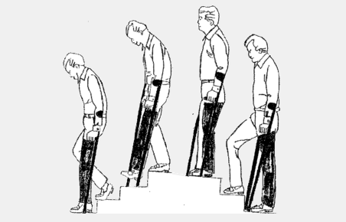
For your safety please check rubber stops, bolts etc remain in good working order.
If faulty return to Physiotherapy for replacement or when crutches are no longer required.

