Discharge advice following attendanwith a HaMetacarpal) Fracture
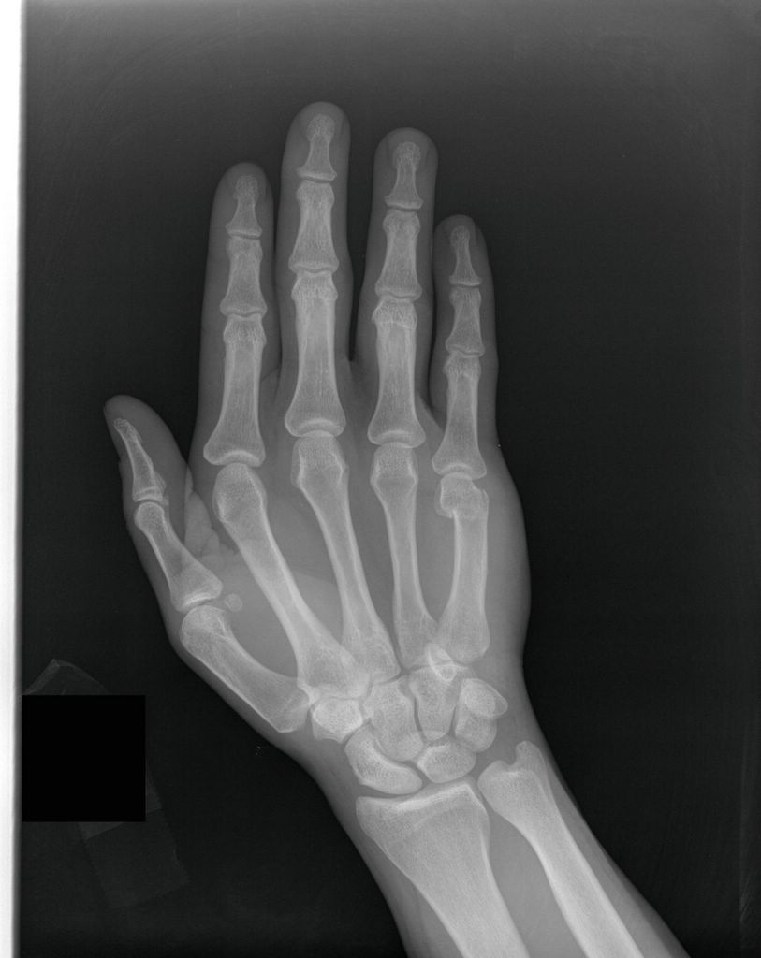
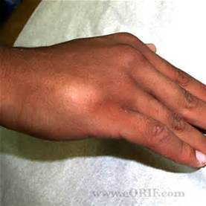
Bendigo Health Emergency Department
Discharge advice following attendance
with a Hand (5th Metacarpal) Fracture.Discharge advice following attendance
with a Hand (5th Metacarpal) Fracture
• You have a minor break near the 5th knuckle, often called a
‘Boxer’s fracture. Pain usually settles in three to four weeks.
• It may take up to six weeks or longer before your fracture heals
completely and your hand function returns to normal though.
• You will initially be treated with your 4-5th fingers taped together
and a ½ plaster slab on the inside of your hand and wrist
• After 2 weeks you may remove the plaster slab but continue
to tape your 4-5th fingers together for up to 4 weeks total.

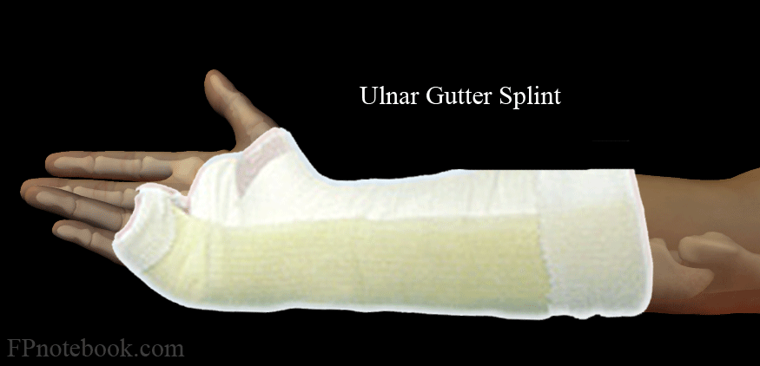
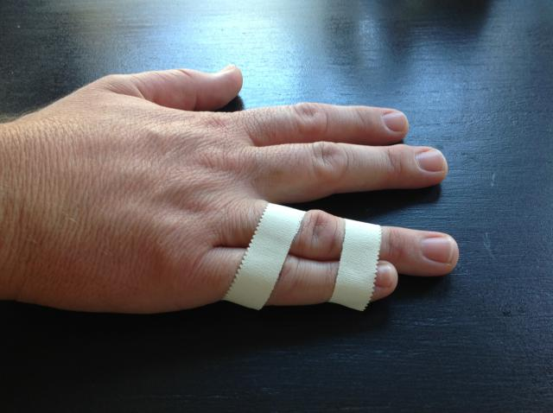
• Because the break can be close to the joint
you must move your hand and fingers even if this means
overcoming some discomfort initially.
• Use your hand as normally as possible. This
will not cause further damage but heavy lifting or contact sports
may be sore for up to 6 weeks or so.
• Hand grip is generally very good after this type of injury
• As the bone heals a lump will form at the break
site and the knuckle will not be as prominent.
• There may be some metacarpal shortening expected as a
consequence of the injury.

If the pain gets worse, or lasts more than 4-6 weeks, or you are concerned about your hand, contact your GP or:
Call the Hand Clinic at John Lindel Rehab Unit on 54548500

