ACTICOAT APPLICATION

- Clean burn with N/Saline or blue chlorhexidine, remove all dead, blistered and loose skin.
- Rinse with water if using Acticoat.
- Select either Acticoat 3 or Acticoat 7 and moisten with Sterile Water.
- Select either Intrasite Conformable or Intrasite Gel (apply gel to gauze), and place on top of moistened Acticoat.
- Cover Acticoat and Intrasite with Glad Wrap (ensure glad wrap doesn’t come into contact with patients skin.

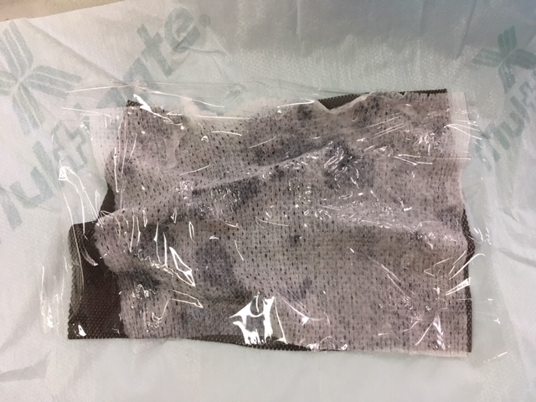

- Apply Acticoat side to burn, try to keep to burnt area only.
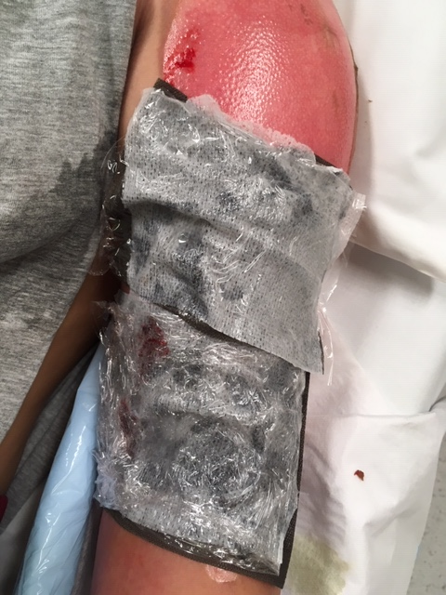

- Secure with Hypafix