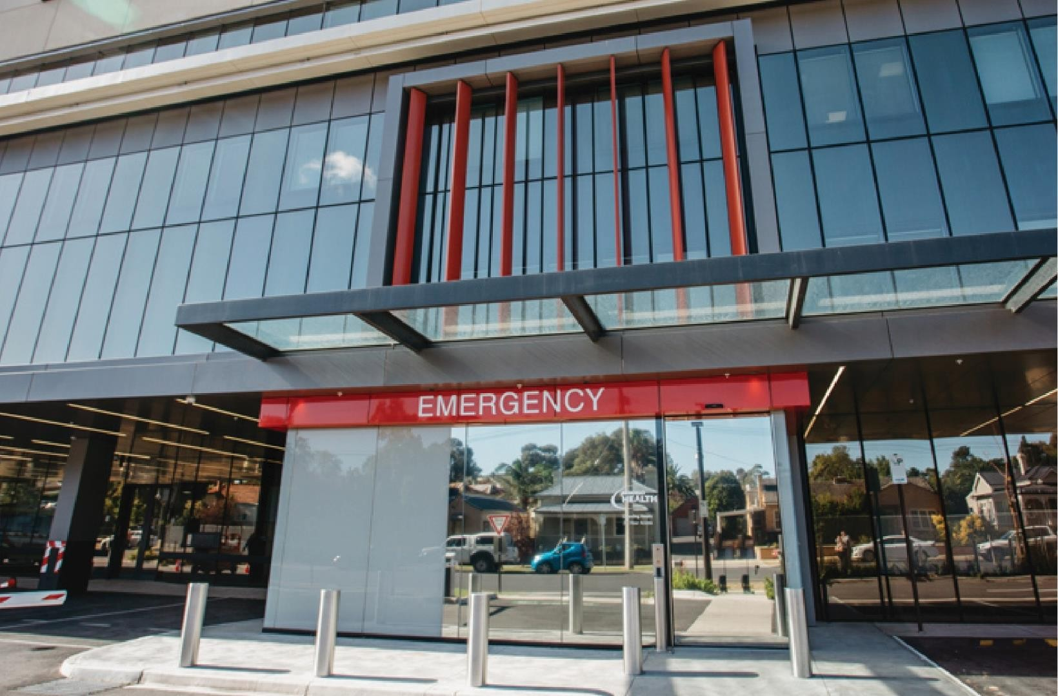

TEAM NURSING
MODEL OF CARE
A Guide for Nursing Staff

February 2019
(Reviewed and updated 10/2019)
INTRODUCTION

This is the outline of the Team Model of Care (MOC) for all Nurses working in the Emergency Department at Bendigo Health.

The Emergency Department by nature is a busy and unpredictable environment where the workload of nurses can change in an instant. Bendigo Emergency Department provides care for approximately 57,000 patients each year, making it one of the busiest emergency departments in regional Victoria. Throughput of patients is constant and the needs of individual patients can vary greatly.

Traditionally in the Emergency Department at Bendigo Health nurses were allocated 3 patients and managed patients independent of other nursing team members.

The objective of team nursing is to give the best possible quality of patient care by utilizing the skills and abilities of each staff member to the fullest extent by appropriately allocating teams to areas that best suit their skills and abilities. Working as a team helps to reduce workload, provides safe, effective, timely care and reduces staff stress, allowing for appropriate definitive patient care.

TEAM NURSING MODEL OF CARE

This MOC is a team focused model for nursing staff, where nurses are allocated zones to “share” the workload. Instead of one nurse being allocated to 3 cubicles in the main department, two nurses will be allocated to a zone, encompassing 7 cubicles, with one nurse being designated “Clinical Lead”. This team will work together to provide care for their patients, support each other through busy periods, provide clinical advice and support, relieve each other for breaks and provide ongoing support throughout the shift. Communication between team members is a must to ensure that all seven of the patients in the team receive the necessary quality of care.

To compliment this model, bedside handover will continue, to ensure adequate and accurate handover and to improve our customer focus.

Part of this model includes a system for communication between shifts. Prior to each shift
commencing, all staff coming on to shift will meet in the ED Education Room for a ‘huddle’, with the ANUM from the previous shift. This will enable any issues, concerns and communications to be voiced with the oncoming shift. This ‘huddle’ also allows new staff, casual staff, students and visitors to be introduced and orientated to the department and their team prior to commencement of the shift.

Evening staff will remain in the Education room on Monday’s Tuesday’s, and Thursday’s for nursing education, they will have afternoon tea at 1430hrs until 1445hrs and then present to their allocated zone at 1450hrs for bedside handover with the previous shift. On days without education, the time spent prior to afternoon tea will be utilised for policy review, project work, research, debriefing, online learning modules and informal education at the discretion of the ANUM.

This model of care can allow for:

- Nurses with different expertise and training to work more effectively.
- Reduced clinical risk from multiple handovers.
- Ensures a more supportive environment for new staff and non-permanent members to acquire knowledge and skills and be overall more supported.
- Can overall improve the feeling of isolation and allows for a more supportive work environment.
- Ensures that patient can be transferred and cared for by nurses that all know the patients
- Assists for patients that are “difficult” or a heavier workload in nature, reducing levels of stress and isolation.
- Increased patient satisfaction and outcomes as patients and families are able to seek information about their care more easily.
- Reduces the incidence of missed nursing care.
- Increase team morale and allows nursing staff to build new knowledge and skills.

MAIN A/NUM

- Demonstrates comprehensive knowledge and understanding of all Emergency Department Key Performance Indicators (KPI) - ‘time to treatment’, ambulance off-stretcher, 4 hour NEAT and 24 hours stays, along with patient safety and satisfaction.
- Works closely and liaises with the duty consultant to promote optimal patient flow and improve time based KPI’s by completing regular rounding using IT systems- Patient Flow Manager (PFM) and iPM to track patient journey and implement discharge plans.
- Leads ED nursing team ‘Huddle’ at commencement of oncoming shift. Coordinates and allocates access nurse and team nursing zones (Main, SSOU, resus, triage, paeds hub, AC, CIN, ramp).
- Acts as senior nursing decision maker. Actively listens to staff to assist with clinical problem solving / solution finding.
- Communicates with the interdisciplinary team to coordinate and track timely referrals.
- Acts as the primary contact with Patient Access and Demand Coordinator to arrange patient admissions, transfers, personnel and discuss escalation as necessary.
- Identifies SSOU admissions and delegates admission processes as appropriate.
- Address performance issues in real time, escalating to NUM where appropriate.
- Validate and act upon the concerns of all staff.
- Identifies barriers to patient flow. Develops and implements effective strategies to prevent, improve and facilitate clinical decision making to ensure safe timely patient discharge/transfer.
- Liaises with inpatient units ANUM / AGSU /paediatric inreach nurse to organise and prioritise patient handover and transport to the ward.
- Prioritises and allocates staff resources in the event of resuscitation or trauma call, to ensure safe, adequate workload cover.
- Carries shift coordinator phone to ensure timely communication within ED and synergising departments.
- Answers ambulance phone and communicates expected patient arrivals with triage and duty consultant.
- Ensures accurate, timely data entry into iPM and PFM.
- Allocates staff appropriately to clinical areas according skill mix.
- Replaces sick leave for upcoming shifts ensuring appropriate skill mix and documents changes on allocation sheet for Kronos purposes.
- Negotiates a plan to relocate existing AC patients when needed.
- Ensures flow through RAMP.
- Ensures half time huddles are facilitated
- Aim to off load 75% of patients allocated to the RAMP cubicles to be transferred to an alternative location in the department within 30min of transfer to the RAMP zone to ensure capacity for arriving ambulances.

Benefits to half time huddles
  - Ensure all staff feel supported - “No nurse left behind”
  - Improve staff morale
  - Improve and promote a team nursing model of care
  - Addressing deteriorating patients,
  - Ensure ongoing safety, identify risks within the department
  - Expediting Patient Flow
  - Better utilisation of staff recourses
  - Quick education opportunities.

Approximate Times
  - Around 11:00, 17:00 and 00:00

Who Huddles?
  - The ANUM and CCRN 0930/1730 Access leads the huddle.
  - Huddle One: ANUM, Access, Drought team Cubicles (purple) 5,6,7,8,9,10 Iso 15
  - Huddle Two: ANUM, Access, Mercy team Cubicles (yellow) 12,13,14,15,16,17 & Iso 14
  - Huddle Three: ANUM, Access, Resus team (red)
  - Huddle Four: ANUM, Access, Ambulatory Care nurses (blue) and Paeds hub (pink)
  - Huddle Five: ANUM, Access, Triage Nurse/s and ramp (black)
  - Huddle Six: ANUM, Access and SSOU ANUM (green)

Duration and What to include:
  - Each huddle should be no more than 2-3 minutes long.
  - A quick mention of who you are worried about in your cubicles/any deteriorating patients / escalation / plans of care
  - Who is ready for ward transfer?
  - Do you need any assistance?
  - Is anyone feeling overwhelmed/stressed/worried/unable to get to a break/any other concerns?

Post Huddle
  - At the conclusion of the huddle, the ANUM and Access nurse should review any patients of concerns.
  - Alert the duty consultant to any deteriorating patients
  - Move any deteriorating patients to Resus if required.
  - If immediate movement to resus cannot be done, allocate a nurse to the deteriorating patient – e.g. the access nurse, or a nurse who has identified that their patients are safe and stable.
  - Allocate resources as needed to areas of higher acuity.

SSOU A/NUM

- Demonstrates comprehensive knowledge and understanding of all Emergency Department Key Performance Indicators (KPI) - ‘time to treatment’, ambulance off-stretcher, 4 hour NEAT and 24 hours stays, along with patient safety and satisfaction.
- Liaises with triage nurse when streaming straight to SSOU from triage is identified
- Works closely and liaises with the SSOU consultant, JMO to promote optimal patient flow and improve time based KPI’s by completing regular rounding using PFM to track patient journey and implement discharge plans.
- Coordinates and allocates patient care responsibilities in SSOU.
- Acts as SSOU senior nursing decision maker. Actively listens to staff to assist with clinical problem solving /solution finding.
- Communicates with the interdisciplinary team to coordinate and track timely referrals.
- Acts as the SSOU contact with Patient Access and Demand Coordinator to arrange patient admissions, transfers, and personnel and discuss escalation as necessary.
- Carries SSOU coordinator phone to communicate directly with Main ANUM, AC & Main duty consultants to actively identify and facilitate SSOU admissions from Main department, AC and the waiting room
- Identifies barriers to patient flow. Develops and implements effective strategies to prevent, improve and facilitate clinical decision making to ensure safe timely patient discharge/transfer.
- Liaises with inpatient units ANUM / AGSU /paediatric in-reach nurse to organise and prioritise SSOU patient handover and transport to the ward.
- Ensures accurate, timely data entry into iPM and Patient Flow.
- Liaises with AC staff to admit appropriate SSOU patients.

DROUGHT AND MERCY TEAM
- Nurses are allocated to teams of two. Each team encompasses seven cubicles. Mercy 12, 13, 14, 15, 16, 17, Iso 14. Drought 5, 6, 7, 8, 9, 10, Iso 15.
- Each team is to work together to deliver appropriate, safe and timely patient care. There will be no allocated cubicles, only a shared team zone Mercy or Drought.
- Both team members are responsible for ensuring a safe environment for patients in the cubicles, ensuring all cubicles are checked, including oxygen and suction, and restocked as necessary.
- Effectively escalate deteriorating patients via MAC / Code Blue protocols.
- Update journey boards at commencement of shift.
- Ensure appropriate clinical guidelines and pathways are adhered to.
- All patients to be visibly checked at least 15 minutely and vital signs recorded a minimum of hourly or as clinically indicated.
- Patients admitted and awaiting transfer to inpatient units should have their vital signs taken at a minimum every four hours unless clinically indicated more frequently (excluding Intensive care/ HDU patients).
- There must be one member of the team in the clinical area at all times.
- Ensure each team member has a meal break at appropriate times.
- Utilise phone handovers to medical inpatient units were possible and safe to do so.
- Each team is responsible for bedside handover at the completion of each shift.
- Team members are responsible for ensuring that the Patient Flow Manager comments section is up to date.
Allocation
  - Nurses are allocated as teams of two.
  - One nurse from each team to be allocated as the clinical lead.
  - Clinical lead should be an experienced nurse with an understanding of Bendigo Health policies and procedures.

Clinical leads
  - Ensuring each team member has a meal break at appropriate times.
  - Responsible for ensuring that the ‘Nurse Int. of PM’ tab is updated on iPM.
  - Responsible for communicating to the ANUM plans or change of plans for patients.
  - Liaise with the ANUM if a patient clinically deteriorates or requires specific ward requirements (i.e. special, infectious, bariatric, pressure risk.)
  - Liaise with the ANUM if your workload becomes unmanageable, patients breach MAC, team nurse off the ward and a ward transfer required or if you have any general concerns about a patient or colleague.
  - Inform ANUM if patient is on an admission or discharge pathway.
  - Please communicate with your ANUM when your patient’s inpatient admission is completed or identify that they may be suitable for interim orders.
  - Responsible for initiating Team Rapid assessment and planning (RAP’s) every 1/24.

Team RAP’s (Rapid Assessment and Planning)
  - To be completed hourly to ensure appropriate care and evaluation.
  - Patient journey boards to be updated as required, and with any new patient presentations. These are essential to be used to ensure patient centred communication between both the team nurses and the patient, ensuring to include patient and their family in the process.
  - Identify the clinical needs of patients in the zone i.e. how often observations need to be done, which clinical investigations need to be completed, medications that need to be administered.
  - Prioritise and allocate patient needs until the next team RAP.
  - Opportunity to update team member of the clinical details for new presentations in the last hour.
  - All team members need to support each other with workload and patient care, ensuring that recognition of staffing skill is taken into account.
  - Staff need to be open to collaboration and reciprocal feedback to ensure that patient clinical care and needs are being met.

TRIAGE TEAM
- Assesses and triages each patient applying ATS and allocates stream [AC/Main/SSOU/Resus].
- Initiates and implements appropriate triage nursing interventions and organisational guidelines (e.g. first aid and emergency interventions) as necessary. These may include nurse initiated x-rays (NIXR) and nurse initiated pathology (NIP).
- Retains responsibility for patients waiting for initial medical consultation.
- Escalates deteriorating patient or any concerns by direct communication with Main duty consultant and Main ANUM using timely verbal communication, MAC or other code (e.g. code grey)
- Ensures accurate, timely data entry into iPM, PFM and DMR.
- Provides a safe work environment for self and patients by checking availability of PPE, safety equipment and consumables each shift.
- Accurately enters patient details into DD register where required and checks register at change of shift.
- Participates in half time huddles.

CIN (Clinical Initiatives Nurse)
The primary responsibility of the clinical initiatives nurse (CIN) is to assess and initiate care in the Emergency Department waiting room
- Ensure that the triage zone is clean, restocked, safety equipment checked and safe to provide patient care.
- At the commencement of each shift, review the patients waiting to be seen list with the triage nurse to identify the needs of each patient in the waiting room.
- Directly influence the Emergency Department key performance indicator (KPI) ‘time to treatment’
Category one - Immediately Category two - Within 10 minutes Category three- Within 30 minutes Category four - Within one hour Category five - Within two hours
- To manage the waiting room and ensure appropriate investigations and care is given within the patient’s categorised time to treatment.
- Commence investigations and initiate care on each patient where appropriate
- Reassessment in line with ATS triage guidelines
- First aid for injuries – laceraine, dressings, ice, splinting, ring removal etc.
- NIXR (nurse initiated xrays) and NIP (nurse initiated pathology) where appropriate
- ECG’s – have signed by Consultant
- Urinalysis and pregnancy testing
- In consultation with the allocated registrar (the ‘go to’ Dr)
- Medication incl. analgesia, antiemetic’s
- Other X-rays as required (ensure requests are per protocol and within Scope of Practice)
- Cannulation and collection and sending pathology
- Ensure accurate and timely documentation is completed via the patients triage form or DMR detailing assessments and interventions undertaken for each patient.
- Accurately document the nurse the ‘nurse seen by’ time on iPM to ensure accurate performance reporting.
- Review patient investigations and refer the results to the appropriate clinicians.
- If a cat 3 patient has not been seen within 30 mins, cat 4 within 60 mins (ATS recommendations) then the CIN should commence a re- assessment/treatment on this patient. If that patient is found to have deteriorated, liaise with the triage nurse to discuss triage category and expedite care if necessary.

AMBULATORY CARE

- Facilitates the 0930 /1330/ 2200 AC team huddle, identifies team members and patients streamed for AC.
- Utilises iPM and PFM to accept nursing handover of patient care. Identifies priorities and plans for nursing care.
- Liaises with the triage nurse to identify the nursing care requirements of new AC patients in the waiting room awaiting initial medical consultation.
- Effectively escalate deteriorating patients via MAC / Code Blue protocols.
- Transfers patients from the Main waiting room into an AC consultation room.
- AC team to manage the AC waiting room (NOW_ACWR), ensuring relevant nursing assessments, investigations, care and reviews are implemented.
- Documents patient assessments and interventions accurately and contemporaneously in DMR. Accurately enters patient data onto iPM and PFM to reflect current patient activity and physical location
- Directs patients assessed by Decision Making Doctor/s to the treatment room or Ambulatory Care waiting room (NOW_WR) to wait for results and/or further investigations.
- Escalates barriers to flow through AC by direct verbal communication with the Main ANUM.
- Reassesses and reviews AC patients by performing hourly rounding utilising PFM. Plans, prioritises and implements nursing care identified.
- Identifies AC patients requiring complex care, referral to SSOU or inpatient admission. Communicates directly with Main ANUM to coordinate transfer and handover care to Main cubicle nurse. Plans, prioritises and negotiates reallocation of existing AC patients into a Main/SSOU clinical area.
- Accepts delegation of responsibility for patients requiring extended care inside the AC clinical area.
- Performs handover of AC patients at the patient side, including the patient in their care and decision making process.
- Provides a safe work environment for self and patients by checking availability of PPE, safety equipment and consumables each shift.
- Accurately enters patient details into DD register where required and checks register at change of shift.
- Participate in half time huddles

RESUSCITATION BAY TEAM

- The resus nurses are responsible for checking and restocking bedside emergency equipment and resus cubicles as per the checklists at the start of each shift.
- Effectively escalate deteriorating patients via MAC / Code Blue protocols.
- Patient journey boards to be updated at the commencement of each shift and amended with any new patient presentations.
- Ensuring that the ‘Nurse Int. of PM’ tab is updated and ambulance offload times on iPM and actual times are retrospectively entered as necessary.
- Responsible for allocating the Airway/Procedure/Scribe resuscitation roles at the commencement of each shift on the role allocation board for the event of a code blue or trauma call.
- On the occasion that there are no patients in resus, or very few stable patients in resus, and after completion of resus equipment checks, the resus nurse or nurses will assist other areas at the discretion of the ANUM.
- The resus nursing team will liaise with the ANUM when extra resources are needed, they will also notify staff when they are no longer required so they may return to their allocated team.
- Participate in half time huddles.

ACCESS RN

- Regularly liaise with the ANUM for allocation to the department’s greatest need, utilising the half time huddle. These are a good opportunity to determine which teams need further assistance.
- Assist Mercy and Drought nursing teams to workup new patients with a focus on ambulance arrivals/high triage category patients.
- Effectively escalate deteriorating patients via MAC / Code Blue protocols.
- Assist the resus team at the direction of the ANUM with 1:1 or multiple high acuity patients.
- Work with the ANUM to expedite inpatient admissions.
- Relieve ANUM/In Charge nurse for meal breaks. Facilitate meal breaks in other teams if required.
- Help facilitate patient flow through the department
- Hospital code blue and HAT (helicopter assistance team) response.
- Check Metro Trolley (outside of SSOU entrance).
- The access nurse’s primary role and are of concentration is assisting in the main department including the paediatric hub and Drought and Mercy teams. The access nurse should only be in resus at the discretion of the ANUM and if there a multiple high acuity 1:1 patient’s.

RAMP

A nurse will be allocated to this position on an afternoon shift via the staff allocation sheets. This includes triaging ambulance arrivals when and if time permits and will therefore where possible will be staffed with a triage competent or Critical Care trained nurse.

The ANUM will continue to prioritise flow into the emergency department and only utilise the ambulance ramping cubicles 18, 19 and 20 when there are no alternative ED cubicles to offload ambulance patients into.

The role of this nurse is to:
- Liaise with the ANUM when a patient who has arrived by ambulance and needs a cubicle
- Where a cubicle is required (i.e. can’t be unloaded to waiting room due to clinical need) and one within the main department will not be available within a reasonable time, the patient will be decanted to the “Ramping Cubicles” under the care of the Ramping Nurse.
- Effectively escalate deteriorating patients via MAC / Code Blue protocols.
- The RAMP nurse will initiate assessment and interventions for all patients in the RAMP zone and reassess appropriateness for transfer to the waiting room, Ambulatory Care or SSOU.
- Accurate and timely ‘off stretcher’ and ‘nurse seen by’ data should be entered by the RAMP nurse on receiving clinical handover from Ambulance Victoria and initiating patient care.
- Aim to off load 75% of patients allocated to the RAMP cubicles to be transferred to an alternative location in the department within 30min of transfer to the RAMP zone to ensure capacity for arriving ambulances.
- When the RAMP nurse is not required in this role they should contact the ANUM for temporary allocation to a zone of need

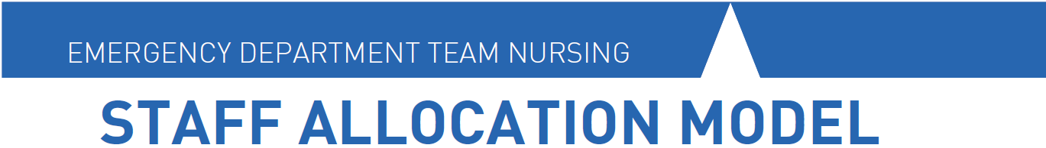
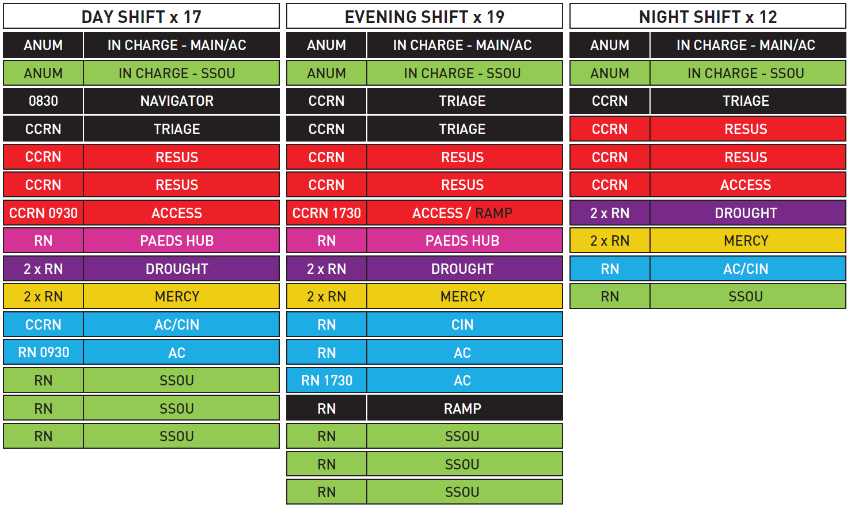
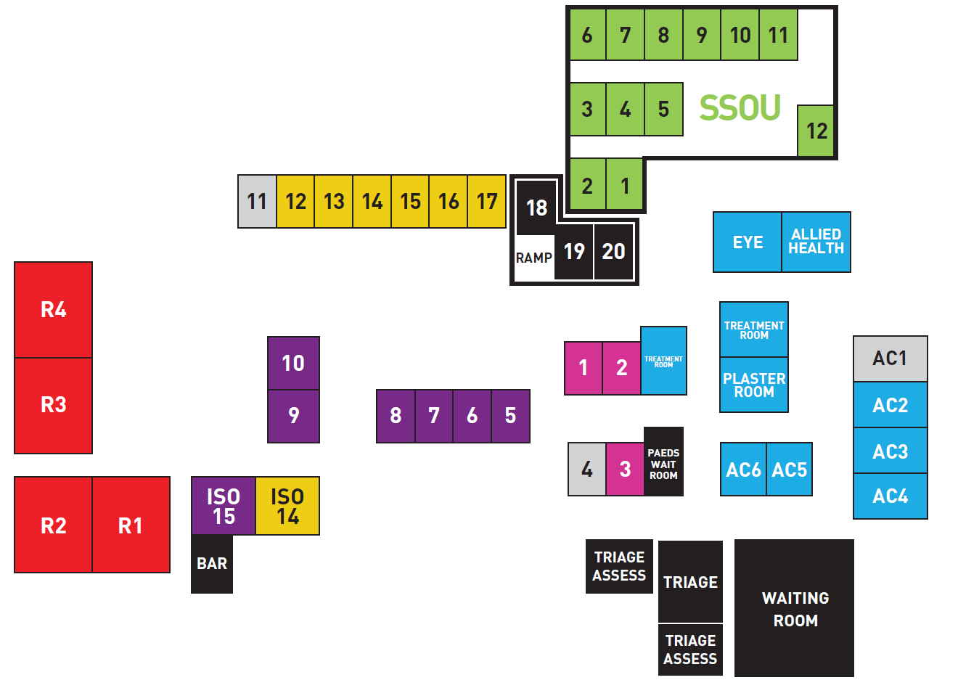

USEFUL LINKS

Bendigo Health Code of Conduct http://prompt1/Search/download.aspx?filename=1048009\1048229\28877550.pdf

Bendigo Health Staff Grievance Resolution Protocol http://prompt1/Search/download.aspx?filename=1048009\1048229\29897901.pdf

Bendigo Health Clinical Handover Protocol http://prompt1/Search/download.aspx?filename=20833342\1290607\31942945.pdf

Bendigo Health Nursing Clinical Documentation Protocol http://prompt1/Search/download.aspx?filename=39835267\39836406\35669202.pdf

Bendigo Health Registered Nurse Initiated X-Rays at Triage in ED Protocol http://prompt1/Search/download.aspx?filename=20833342\1163029\33125311.pdf

Bendigo Health Nurse Initiated Pathology at Triage Policy http://prompt1/Search/download.aspx?filename=20833342\1163029\37384650.pdf

Bendigo Health Emergency Department Patient Discharge Protocol http://prompt1/Search/download.aspx?filename=20833342\1163029\36890149.pdf

ED Central http://www.edcentral.com.au/

College of Emergency Nursing Australia https://www.cena.org.au/

